Woodlands Trail and Park “Creating a Legacy”
Our Lady of Holy Cross College Campus $ 4123 Woodland Drive $ New Orleans, Louisiana 70131
106 Avenue G $ Belle Chasse, Louisiana 70037
Phone/Fax: (504) 433-4000 $ www.woodlandstrail.org $ E-mail: woodlandstrail@aol.com
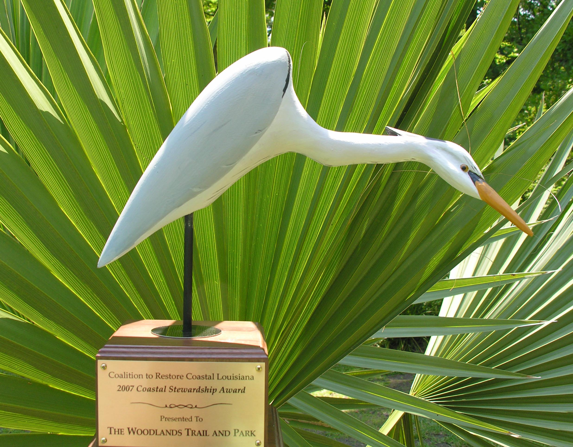

Woodlands Trail and Park Receives Coastal Stewardship Award

FOR IMMEDIATE RELEASE

Date: May 17, 2007
Contact: 504.433.4000 or 504.453.4934

Belle Chasse, Louisiana. Woodlands Trail and Park began as a grassroots effort to increase community access to the river while uniting Orleans and Plaquemines Parish with a series of educational, recreational and historical greenways and trails. On May 11, 2007, Woodlands Trail and Park's efforts in "Creating a Legacy" for future generations were honored by the Coalition to restore Coastal Louisiana. Woodlands Trail and Park Board Members, Katie Brasted, Carol Osborne Cowley and Paul Richard were present at a banquet held at the LSU Faculty Club in Baton Rouge to accept the Coastal Stewardship Award for "preserving, protecting and celebrating the natural beauty and cultural treasures within a 10,000-acre peninsula in the Metropolitan New Orleans area." CRCL’s Board Chairman, Woody Crews, presented this prestigious award that came in the form of a hand-carved Egret. Plaquemines Parish Councilwoman Lynda Banta attended the event with Woodlands Trail and Park Board members and guests. Woodlands Trail and Park’s smart growth regional efforts have gained increased National attention during the past several months following the award for the 2006 Conservation Organization of the Year from the Louisiana Wildlife Federation and the National Wildlife Federation. With the support of partners, Algiers Economic Development Foundation and Our Lady of Holy Cross College, the organization was nominated for the Preserve America Award and has recently received notice of nomination for the Coastal America Award by Doug Meffert, Deputy Director, Tulane/Xavier Center for Bioenvironmental Research.

